Day 399 — AI Engineering Revision
Complete Revision Notes | Flask + AI Integration • REST APIs • Model Serving • Database Integration • Auth & JWT • File Uploads • Security & Deployment
Learning goal: master production AI software engineering: integrate trained machine learning and deep learning models into robust Flask REST APIs; architect low-latency model serving; execute database persistence with SQLAlchemy and PostgreSQL; implement stateless JWT authentication and role-based access control; handle secure multipart file uploads; enforce rigorous schema validation and centralized error handling; deploy via Gunicorn, Nginx, Docker, and Celery asynchronous task queues; and enforce OWASP security and structured logging.

1. Production AI Application Architecture
Transitioning an AI model from a Jupyter Notebook proof-of-concept to an enterprise production service requires wrapping statistical weights in a resilient, decoupled web tier. Machine learning models cannot directly communicate over networks; they require HTTP application gateways to handle authentication, payload serialization, rate limiting, and database state management.
A production-grade AI system adopts a 4-tier microservice architecture: Client Presentation Layer, Reverse Proxy & Security Gateway, WSGI Application Server running Flask/FastAPI workers, and Data & Model Artifact Stores.
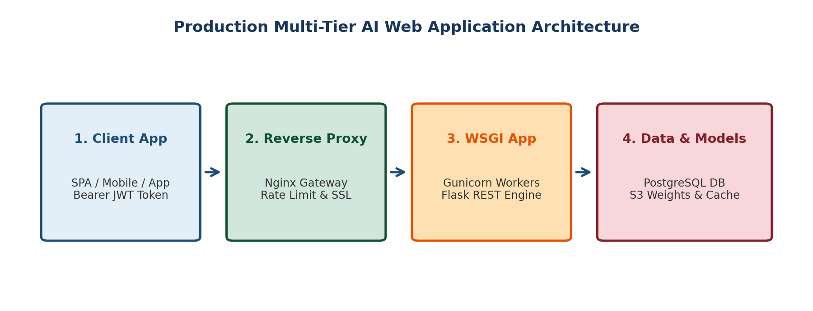
Figure 1. Production multi-tier AI web application architecture spanning Client Ingress, Nginx Reverse Proxy, Gunicorn Flask WSGI workers, and Database/Storage.
Architecture Tier | Technology Stack | Core Engineering Responsibility | Production Best Practice
1. Client / Ingress | React / Vue SPA, Mobile iOS/Android, External B2B APIs | Issues HTTP REST / gRPC requests with JSON payloads and Bearer JWT authorization headers | Always enforce HTTPS/TLS; implement client-side input validation before sending payloads
2. Reverse Proxy & Gateway | Nginx, Cloudflare, Traefik, AWS API Gateway | SSL/TLS termination, DDoS mitigation, IP rate limiting, buffering slow clients, static asset caching | Nginx acts as reverse proxy protecting upstream Python application servers from direct internet exposure
3. Application / WSGI Tier | Gunicorn / uWSGI + Flask 3.x (Python) | Routing, request deserialization, token verification, business logic, model inference execution | Run pre-fork worker model (e.g., 2-4 workers per CPU core); never run the built-in Flask development server in production
4. Persistence & Model Stores | PostgreSQL (SQLAlchemy ORM), Redis (Cache), AWS S3 / MinIO | Stores user credentials, audit trails, and transactional records; caches embeddings; persists model checkpoints | Load heavy model weights into memory ONCE during application startup (pre-fork or worker init), never per request

2. RESTful AI API Design & Inference Lifecycle
Representational State Transfer (REST) is the architectural standard for stateless web APIs. A properly designed AI REST API treats predictions, models, tasks, and datasets as identifiable web resources manipulated via standard HTTP methods.
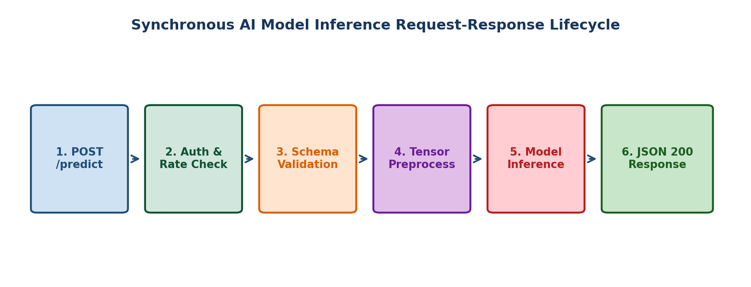
Figure 2. Step-by-step lifecycle of a synchronous AI inference request from HTTP ingress to validated JSON response.
HTTP Method | Canonical Endpoint | Action Performed | Expected HTTP Status Code
POST | /api/v1/predict | Submit feature payload for synchronous model inference | 200 OK (with prediction JSON) or 400 Bad Request
POST | /api/v1/tasks/predict-async | Submit heavy image/video for background asynchronous processing | 202 Accepted (returns task_id for status polling)
GET | /api/v1/tasks/<task_id> | Poll execution status and retrieve async inference results | 200 OK (status: SUCCESS/PENDING) or 404 Not Found
GET | /api/v1/models/health | Readiness and liveness probe for Kubernetes load balancers | 200 OK (returns memory usage, model version, uptime)
POST | /api/v1/models/reload | Trigger zero-downtime hot reloading of updated model weights | 200 OK (admin/internal network restricted)

The 6-Stage Inference Request-Response Lifecycle
Lifecycle Trace: POST /api/v1/predict:
1. Ingress & TLS Termination: Nginx decrypts TLS, verifies rate limits, and proxies to Gunicorn socket.
2. Authentication & Guardrails: Flask before_request hook validates JWT signature and checks user quota.
3. Schema Validation: Marshmallow or Pydantic parses request body, asserting types and bounds.
4. Preprocessing: Extracted features are converted to NumPy/Pandas and transformed via fitted scaler/pipeline.
5. Model Inference: Preprocessed tensor is passed to model.predict_proba(); output logits are extracted.
6. Response Packaging: Prediction and confidence score are formatted as JSON, logged, and returned with HTTP 200.

3. Model Serving Paradigms: Memory Management & Latency
Serving machine learning models in web applications introduces unique memory and CPU/GPU bottlenecks. Naive implementations frequently crash production servers by loading model files on every single incoming HTTP request.
Serving Paradigm | Technical Mechanism | Typical Latency | Ideal Use Case
In-Process Synchronous Serving | Model artifact (.joblib / .onnx) loaded into Flask global application memory during startup | 10ms – 100ms | Low-latency tabular models (XGBoost, Random Forest, Logistic Regression) handling real-time requests
Asynchronous Background Queue | Flask accepts request, enqueues payload into Redis/RabbitMQ, and Celery workers execute inference | 500ms – 30s+ | Heavy deep learning models (ResNet, Whisper, LLMs), batch document OCR, and video processing
Dedicated Model Servers | Specialized C++ inference engines (Triton Inference Server, TorchServe, vLLM, TF Serving) | Sub-5ms | High-throughput microservices requiring dynamic batching, GPU memory paging, and model pipelining
Serverless Inference | Cloud functions (AWS Lambda, Google Cloud Run) with containerized weights | Cold: 3-8s; Warm: 50ms | Sporadic, unpredictable traffic with low baseline volume and cost-sensitive budgets

Singleton Model Loader Pattern in Python
To prevent memory bloat and duplicate weight allocations across worker threads, wrap the model inside a Singleton wrapper:
import joblib
import os

class ModelService:
_instance = None
_model = None

@classmethod
def get_model(cls):
if cls._model is None:
model_path = os.getenv("MODEL_PATH", "models/random_forest_v1.joblib")
print(f"Loading model into memory from {model_path}...")
cls._model = joblib.load(model_path)
print("Model loaded successfully.")
return cls._model

# In Flask route:
# model = ModelService.get_model() <-- Instantaneous retrieval from RAM!

4. Database Integration & ORM with Flask-SQLAlchemy
Production AI systems require relational persistence to store user accounts, track inference request logs, record predicted vs actual outcomes for data drift auditing, and maintain model registry metadata. Flask-SQLAlchemy abstracts raw SQL queries into Pythonic Object-Relational Mapping (ORM).
Database Component | Technology / Pattern | Role in AI Engineering
Flask-SQLAlchemy | ORM abstraction layer | Maps Python classes directly to PostgreSQL database tables; manages connection pooling
Flask-Migrate (Alembic) | Schema version control | Tracks database schema modifications over time (db init, db migrate, db upgrade) without data loss
Connection Pooling | QueuePool (pool_size=10, max_overflow=20) | Maintains warm, persistent database connections; prevents connection exhaustion under heavy load
Prediction Audit Table | Relational audit entity | Stores: request_id, input_features (JSONB), predicted_class, latency_ms, actual_outcome (for drift)

5. Authentication & Role-Based Authorization (JWT)
Exposing machine learning APIs publicly without authentication leads to unauthorized compute theft, denial-of-service, and credential harvesting. JSON Web Tokens (JWT) provide stateless, cryptographically signed authentication.
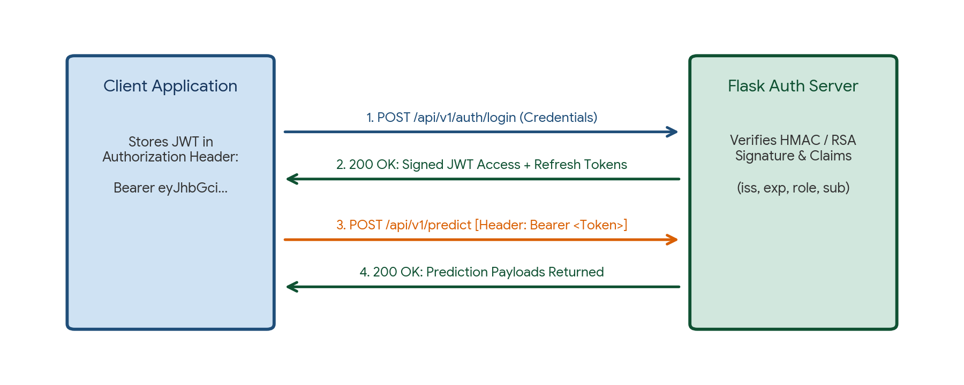
Figure 3. Stateless JWT authentication handshake: Credential verification -> Signed Bearer token emission -> Protected inference request.
JWT Segment | Contents & Structure | Security & Verification Mechanism
Header | {'alg': 'HS256', 'typ': 'JWT'} | Specifies hashing algorithm (HMAC SHA-256 or RSA-256); base64url encoded
Payload (Claims) | {'sub': user_id, 'role': 'admin', 'exp': 1718000000, 'iat': 1717000000} | Stores public identity claims; expiration timestamp (exp) enforces automatic session termination
Signature | HMAC-SHA256(base64UrlEncode(Header) + '.' + base64UrlEncode(Payload), SECRET_KEY) | Guarantees token tamper-proofing. Tampering with role or user_id invalidates the signature

Custom Auth Decorator with Role Enforcement
from functools import wraps
from flask import request, jsonify
import jwt
import os

SECRET_KEY = os.getenv("JWT_SECRET_KEY", "super-secure-production-key")

def token_required(allowed_roles=None):
def decorator(f):
@wraps(f)
def decorated(*args, **kwargs):
auth_header = request.headers.get("Authorization", None)
if not auth_header or not auth_header.startswith("Bearer "):
return jsonify({"error": "Missing or malformed Authorization header"}), 401

token = auth_header.split(" ")[1]
try:
payload = jwt.decode(token, SECRET_KEY, algorithms=["HS256"])
user_role = payload.get("role", "user")
if allowed_roles and user_role not in allowed_roles:
return jsonify({"error": "Forbidden: Insufficient privileges"}), 403
except jwt.ExpiredSignatureError:
return jsonify({"error": "Token expired. Please re-authenticate"}), 401
except jwt.InvalidTokenError:
return jsonify({"error": "Invalid token"}), 401

return f(current_user=payload, *args, **kwargs)
return decorated
return decorator

6. Secure Multipart File Uploads & Asynchronous Queues
Vision, audio, and document AI systems require endpoints capable of handling multipart/form-data file uploads. Naively saving user-submitted filenames to the local filesystem exposes servers to catastrophic Path Traversal attacks (e.g., ../../etc/passwd) and remote code execution.
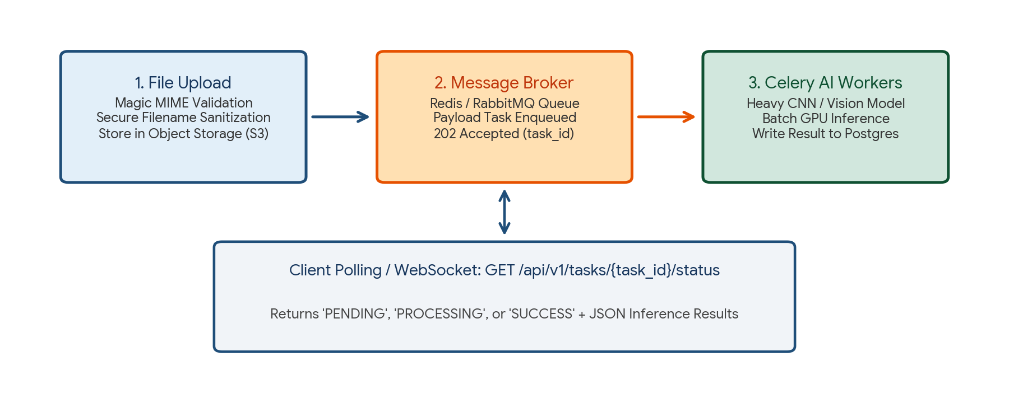
Figure 4. Secure multipart file upload validation, object storage persistence, and Celery asynchronous background processing.
Security Vector | Exploit Mechanism | Robust Defense Strategy
Filename Spoofing | Attacker submits file named '../../etc/cron.d/malicious' | Sanitize with werkzeug.utils.secure_filename(); rename to UUID4.ext internally
Extension Spoofing | Attacker names executable file 'exploit.php.jpg' to bypass extensions | Inspect binary file headers using python-magic (libmagic) to verify true MIME type
Payload Denial of Service | Attacker uploads a 10GB file to exhaust server memory/disk | Enforce strict ceiling via app.config['MAX_CONTENT_LENGTH'] = 16 * 1024 * 1024 (16MB)
Blocking Event Loop | Processing high-res images synchronously blocks the WSGI worker | Save raw file to S3/MinIO; enqueue task to Celery/Redis; return 202 Accepted

7. Input Validation & Centralized Error Handling
Machine learning algorithms expect strictly typed numerical tensors with exact column dimensionalities. Passing a string or null value into a Scikit-Learn pipeline causes an unhandled 500 Internal Server Error. Robust AI applications enforce strict schema validation at the HTTP boundary.
Validation Tool | Execution Mechanism | When to Use
Pydantic / Marshmallow | Defines strict object schemas with type casting and custom boundary assertions (e.g., age must be 18–100) | Validating JSON input payloads before feature extraction
Custom Exception Handlers | Flask @app.errorhandler(400) and @app.errorhandler(Exception) | Intercepts all unhandled exceptions; returns standardized JSON error envelopes; prevents stack trace leaks
HTTP Status Code Standards | Returns 400 (Bad Data), 401 (Unauth), 403 (Forbidden), 422 (Unprocessable), 500 (Internal) | Enforces API contracts for predictable client error handling

Centralized JSON Error Envelope Format
# Production Standard JSON Error Envelope:
{
"status": "error",
"error_code": "INVALID_FEATURE_PAYLOAD",
"message": "Field 'Annual_Income' must be a positive numerical float.",
"details": {
"field": "Annual_Income",
"received": -5000,
"constraint": "min_value: 0"
},
"timestamp": "2026-11-03T11:46:00Z"
}

8. Defense-in-Depth Security & Structured Observability
Securing an AI application requires multi-layered defense-in-depth across the network, application, model, and database layers, combined with structured logging for anomaly tracking.
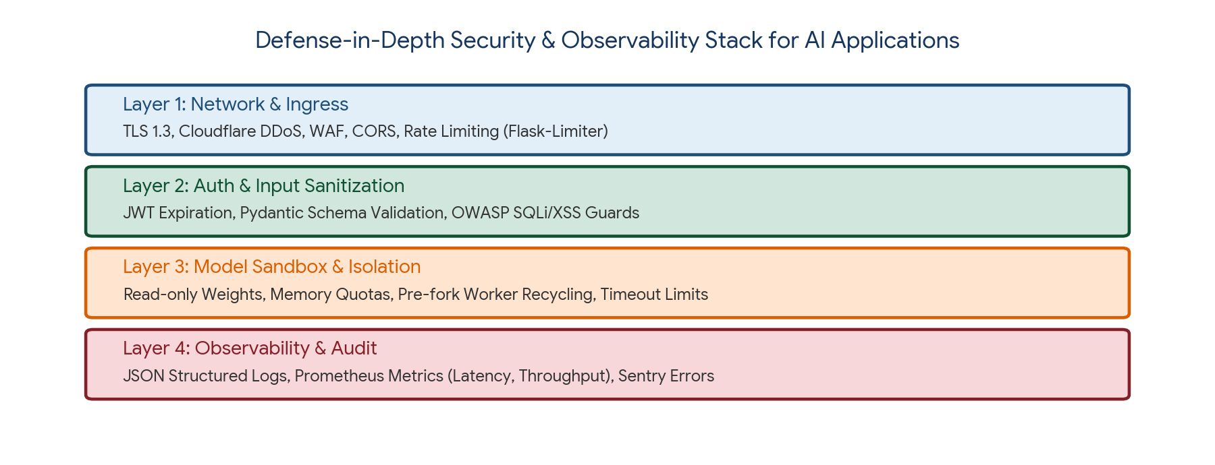
Figure 5. Defense-in-depth security layers and observability stack for production AI web microservices.
Security / Ops Layer | Technology / Practice | Core Operational Safeguard
Rate Limiting | Flask-Limiter + Redis backend | Restricts abusive IPs (e.g., '100 requests/minute'); prevents brute-force scraping and compute exhaustion
CORS Protection | Flask-CORS (Cross-Origin Resource Sharing) | Restricts API access strictly to designated whitelist origins (e.g., https://app.company.com)
Structured Logging | Python logging with JSONFormatter (python-json-logger) | Outputs structured JSON logs: timestamp, level, endpoint, latency_ms, status_code (ingested by ELK / Datadog)
Model Security | Read-only file permissions (chmod 400); safe serialization | Never unpickle untrusted .pkl files (code execution risk); prefer safetensors / ONNX / joblib
Environment Configuration | python-dotenv + HashiCorp Vault | Isolates database passwords, JWT secrets, and API keys completely out of source control

9. Production Deployment: Gunicorn, Nginx, and Docker
Deploying an AI application requires wrapping the Python code into an immutable, reproducible container orchestrated by production-grade servers.
Deployment Component | Configuration Setting | Purpose & Rationale
Gunicorn WSGI Server | gunicorn -w 4 -k gthread --threads 2 -b 0.0.0.0:5000 wsgi:app | Manages pre-fork worker processes; handles concurrent threads; automatically restarts crashed workers
Worker Math Formula | workers = (2 × CPU_Cores) + 1 | Optimal worker count balancing CPU utilization with operating system context switching overhead
Nginx Configuration | proxy_pass http://127.0.0.1:5000; client_max_body_size 16M; | Buffers slow HTTP clients; terminates SSL; forwards clean requests to internal Gunicorn socket
Docker Containerization | Multi-stage Dockerfile based on python:3.11-slim | Packages application code, system C libraries (libgomp, libmagic), and Python dependencies into a 400MB image

10. Practical Project — Enterprise Production AI Microservice Engine
Objective: design, build, and benchmark a complete, modular, enterprise-grade production Flask AI microservice. The service implements Singleton model caching, Pydantic schema validation, JWT authentication, secure file upload verification, centralized error handlers, structured logging, and health metrics endpoints.

Project structure
flask_ai_production_engine/
|
|-- app/
| |-- __init__.py (Application factory)
| |-- config.py (Environment configurations)
| |-- auth.py (JWT token generation & decorators)
| |-- models.py (SQLAlchemy database tables)
| |-- schemas.py (Pydantic input validation)
| |-- routes.py (Inference & upload endpoints)
| |-- services.py (Singleton model loader)
|
|-- models/
| |-- credit_model.joblib (Trained ML model weights)
|
|-- reports/
| |-- test_inference_report.json
|
|-- wsgi.py (Production entry point)
|-- Dockerfile (Multi-stage container definition)
|-- requirements.txt (Pinned production dependencies)

requirements.txt
Flask==3.0.3
gunicorn==22.0.0
PyJWT==2.8.0
pydantic==2.7.4
scikit-learn==1.5.0
joblib==1.4.2
python-magic==0.4.27
Flask-SQLAlchemy==3.1.1
Flask-Limiter==3.7.0

Complete Production Application Implementation
import os
import json
import uuid
import jwt
import joblib
import numpy as np
import pandas as pd
from datetime import datetime, timedelta, timezone
from functools import wraps
from pydantic import BaseModel, Field, ValidationError
from flask import Flask, request, jsonify
from werkzeug.utils import secure_filename
from sklearn.ensemble import RandomForestClassifier

# ---------------------------------------------------------
# 1. APPLICATION SETUP & CONFIGURATION
# ---------------------------------------------------------
app = Flask(__name__)
app.config["SECRET_KEY"] = os.getenv("SECRET_KEY", "prod-ai-secret-key-2026")
app.config["MAX_CONTENT_LENGTH"] = 16 * 1024 * 1024 # 16 MB max
UPLOAD_FOLDER = os.path.join(os.getcwd(), "uploads")
os.makedirs(UPLOAD_FOLDER, exist_ok=True)
os.makedirs("reports", exist_ok=True)

# ---------------------------------------------------------
# 2. SINGLETON MODEL SERVICE
# ---------------------------------------------------------
class ModelService:
_model = None

@classmethod
def load_or_train_model(cls):
if cls._model is None:
# Simulate a pretrained Credit Risk Random Forest
np.random.seed(42)
X_dummy = np.random.normal(50, 15, (200, 3))
y_dummy = (X_dummy[:, 0] * 0.05 + X_dummy[:, 1] * 0.02 > 3.0).astype(int)
clf = RandomForestClassifier(n_estimators=50, random_state=42)
clf.fit(X_dummy, y_dummy)
cls._model = clf
print("Production Random Forest Model cached in memory.")
return cls._model

# Initialize model on startup
ModelService.load_or_train_model()

# ---------------------------------------------------------
# 3. PYDANTIC VALIDATION SCHEMAS
# ---------------------------------------------------------
class CreditInferenceRequest(BaseModel):
annual_income: float = Field(..., gt=0, description="Annual income in USD")
debt_ratio: float = Field(..., ge=0.0, le=1.0, description="Debt-to-income ratio (0.0 to 1.0)")
credit_score: float = Field(..., ge=300, le=850, description="FICO score (300 to 850)")

# ---------------------------------------------------------
# 4. AUTHENTICATION & JWT DECORATORS
# ---------------------------------------------------------
def generate_jwt(user_id, role="user"):
payload = {
"sub": user_id,
"role": role,
"exp": datetime.now(timezone.utc) + timedelta(hours=2),
"iat": datetime.now(timezone.utc)
}
return jwt.encode(payload, app.config["SECRET_KEY"], algorithm="HS256")

def require_auth(allowed_roles=None):
def decorator(f):
@wraps(f)
def decorated_function(*args, **kwargs):
auth_header = request.headers.get("Authorization", None)
if not auth_header or not auth_header.startswith("Bearer "):
return jsonify({"status": "error", "message": "Missing Bearer token"}), 401

token = auth_header.split(" ")[1]
try:
payload = jwt.decode(token, app.config["SECRET_KEY"], algorithms=["HS256"])
if allowed_roles and payload.get("role") not in allowed_roles:
return jsonify({"status": "error", "message": "Forbidden privileges"}), 403
except jwt.ExpiredSignatureError:
return jsonify({"status": "error", "message": "Token expired"}), 401
except jwt.InvalidTokenError:
return jsonify({"status": "error", "message": "Invalid token"}), 401

return f(current_user=payload, *args, **kwargs)
return decorated_function
return decorator

# ---------------------------------------------------------
# 5. REST API ROUTES
# ---------------------------------------------------------
@app.route("/api/v1/health", methods=["GET"])
def health_check():
return jsonify({
"status": "healthy",
"model_loaded": ModelService._model is not None,
"timestamp": datetime.now(timezone.utc).isoformat()
}), 200

@app.route("/api/v1/auth/token", methods=["POST"])
def get_auth_token():
# Public token issue endpoint for testing
token = generate_jwt("user-prod-101", role="analyst")
return jsonify({"access_token": token, "token_type": "Bearer"}), 200

@app.route("/api/v1/predict", methods=["POST"])
@require_auth(allowed_roles=["admin", "analyst", "user"])
def predict(current_user):
start_time = datetime.now()
raw_data = request.get_json(silent=True)
if not raw_data:
return jsonify({"status": "error", "message": "Missing JSON request body"}), 400

# Pydantic validation
try:
validated_input = CreditInferenceRequest(**raw_data)
except ValidationError as e:
return jsonify({
"status": "error",
"message": "Input validation error",
"errors": e.errors()
}), 422

# Model inference
model = ModelService.load_or_train_model()
features = np.array([[
validated_input.annual_income / 1000.0,
validated_input.debt_ratio * 100.0,
validated_input.credit_score / 10.0
]])
prediction = int(model.predict(features)[0])
probabilities = model.predict_proba(features)[0].tolist()

latency_ms = (datetime.now() - start_time).total_seconds() * 1000.0

response_payload = {
"status": "success",
"prediction": prediction,
"prediction_label": "High_Risk_Default" if prediction == 1 else "Approved",
"default_probability": round(probabilities[1], 4),
"latency_ms": round(latency_ms, 2),
"requested_by": current_user["sub"]
}
return jsonify(response_payload), 200

@app.route("/api/v1/upload-file", methods=["POST"])
@require_auth(allowed_roles=["admin", "analyst"])
def upload_file(current_user):
if "file" not in request.files:
return jsonify({"status": "error", "message": "No file part in request"}), 400

file = request.files["file"]
if file.filename == "":
return jsonify({"status": "error", "message": "No selected file"}), 400

filename = secure_filename(file.filename)
allowed_extensions = {".csv", ".json", ".txt"}
ext = os.path.splitext(filename)[1].lower()

if ext not in allowed_extensions:
return jsonify({"status": "error", "message": f"Extension {ext} not permitted"}), 415

unique_filename = f"{uuid.uuid4().hex}_{filename}"
filepath = os.path.join(UPLOAD_FOLDER, unique_filename)
file.save(filepath)

return jsonify({
"status": "success",
"message": "File uploaded and validated successfully",
"stored_filename": unique_filename,
"file_size_bytes": os.path.getsize(filepath)
}), 201

# ---------------------------------------------------------
# 6. CENTRALIZED ERROR HANDLERS
# ---------------------------------------------------------
@app.errorhandler(404)
def not_found(e):
return jsonify({"status": "error", "message": "Resource endpoint not found"}), 404

@app.errorhandler(405)
def method_not_allowed(e):
return jsonify({"status": "error", "message": "HTTP Method not permitted"}), 405

@app.errorhandler(500)
def internal_error(e):
return jsonify({"status": "error", "message": "Internal server processing error"}), 500

# ---------------------------------------------------------
# 7. EXECUTION & AUTOMATED BENCHMARKING
# ---------------------------------------------------------
def run_automated_test():
with app.test_client() as client:
# Step 1: Health check
res_health = client.get("/api/v1/health")
print("Health Check Response:", res_health.get_json())

# Step 2: Get JWT Token
res_token = client.post("/api/v1/auth/token")
token = res_token.get_json()["access_token"]
headers = {"Authorization": f"Bearer {token}"}

# Step 3: Run Valid Prediction
valid_payload = {
"annual_income": 85000.0,
"debt_ratio": 0.28,
"credit_score": 740.0
}
res_pred = client.post("/api/v1/predict", json=valid_payload, headers=headers)
print("\nValid Inference Response:")
print(json.dumps(res_pred.get_json(), indent=2))

# Save test report
with open("reports/test_inference_report.json", "w") as f:
json.dump(res_pred.get_json(), f, indent=2)

# Step 4: Test Validation Error (Negative income & out-of-range credit score)
invalid_payload = {
"annual_income": -100.0,
"debt_ratio": 1.5,
"credit_score": 950.0
}
res_invalid = client.post("/api/v1/predict", json=invalid_payload, headers=headers)
print("\nInvalid Payload Rejection (HTTP 422):")
print(json.dumps(res_invalid.get_json(), indent=2))

if __name__ == "__main__":
run_automated_test()

Run the project
pip install -r requirements.txt
python main.py

Expected generated outputs
reports/
|-- test_inference_report.json

Project notes: utilizing the Singleton pattern guarantees that the Random Forest estimator is instantiated in memory only once. Pydantic strictly intercepts corrupt input tensors before model execution, eliminating runtime mathematical crashes.

11. Common Mistakes & Anti-Patterns to Avoid in AI Engineering
- Reloading model weights on every HTTP request: Calling joblib.load() inside the route handler reads weights from disk on every invocation, spiking latency from 15ms to 2500ms.
- Running Flask's built-in WSGI development server in production: Flask's default server is single-threaded and unbuffered, easily exhausted by slow clients or low-volume attacks.
- Using Python's native pickle module on untrusted network data: Deserializing pickle bytes allows arbitrary Python code execution; use safetensors, ONNX, or JSON feature inputs.
- Hardcoding database credentials and JWT secrets in source code: Secret keys committed to Git repositories invite credential compromise; load secrets via environment variables.
- Omitting client payload size limits: Failing to configure MAX_CONTENT_LENGTH permits denial-of-service via massive file upload memory exhaustion.
- Leaking internal stack traces in HTTP responses: Returning raw Python exception tracebacks exposes database schemas, directory structures, and library versions to attackers.
- Blocking synchronous WSGI workers with heavy vision/audio models: Long-running model inference (e.g., Whisper, Stable Diffusion) starves the Gunicorn worker pool; delegate to Celery.

12. Quick Revision — Key Differences
Comparison | First Concept | Second Concept
Flask vs FastAPI | Synchronous WSGI standard; lightweight, mature, vast ecosystem | Asynchronous ASGI framework; native async/await, automatic OpenAPI/Swagger docs
In-Process vs Out-of-Process Serving | Model loaded into web app RAM; lowest latency for tabular ML | Dedicated model service (Triton / TorchServe); dynamic GPU batching for deep nets
Synchronous vs Asynchronous APIs | Client blocks and waits for immediate HTTP 200 response (sub-200ms) | Client receives HTTP 202 Accepted; polls worker queue status or uses WebSockets
Authentication vs Authorization | Verifying identity: 'Who are you?' (via Password / JWT) | Enforcing permissions: 'What are you allowed to do?' (via Roles / Scopes)
WSGI vs Reverse Proxy | Gunicorn: Executes Python code and manages worker process lifecycle | Nginx: Terminates SSL/TLS, buffers slow clients, and enforces rate limits
Data Drift vs Concept Drift | Input feature distribution P(X) changes over time | Relationship between features and target P(y|X) changes over time

13. Important Architectural Commands & Configuration Cheat Sheet
Tool / Process | Production CLI Command / Syntax Pattern
Gunicorn Execution | gunicorn -w 4 -k gthread --threads 2 -b 0.0.0.0:5000 --timeout 120 wsgi:app
Celery Worker Launch | celery -A tasks.celery_app worker --loglevel=info --concurrency=2
Alembic Migration | flask db migrate -m 'Add prediction audit table' && flask db upgrade
Docker Build & Run | docker build -t ai-service:v1 . && docker run -p 5000:5000 --env-file .env ai-service:v1
File Sanitization | from werkzeug.utils import secure_filename; safe_name = secure_filename(file.filename)
JWT Generation | jwt.encode({'sub': user_id, 'exp': datetime.utcnow() + timedelta(hours=1)}, SECRET, algorithm='HS256')
Gunicorn Worker Formula | Number of Workers = (2 × CPU Cores) + 1

14. Interview / Viva Questions
Why is Flask's built-in development server unsuitable for production?
It is single-threaded, lacks process supervision, does not buffer slow network connections, and crashes under concurrent traffic. Production requires a robust WSGI server like Gunicorn backed by Nginx.
How do you prevent memory leaks when serving ML models in Python?
1. Load the model once as a singleton at application startup; 2. Pre-fork workers properly; 3. Use gunicorn --max-requests 1000 to periodically recycle workers and clear Python heap fragmentation; 4. Use PyTorch torch.no_grad() during inference.
What is the role of Gunicorn in an AI web application?
Gunicorn is a WSGI HTTP server that translates incoming HTTP requests from Nginx into the WSGI standard that Flask understands, managing a pre-fork pool of worker processes for concurrent execution.
Why place Nginx in front of Gunicorn?
Nginx handles SSL/TLS encryption, serves static assets, mitigates slow-client attacks by buffering incoming requests, manages rate limiting, and routes traffic across multiple backend Gunicorn instances.
How does JWT authentication work in stateless REST APIs?
The client exchanges credentials for a cryptographically signed token containing claims and an expiration time. On subsequent requests, the client passes this token in the Authorization header. The server verifies the signature without needing a database session lookup.
What is Path Traversal in file uploads and how do you prevent it?
An attack where filenames contain directory climbing sequences (e.g., ../../etc/passwd) to overwrite sensitive system files. Prevented using werkzeug.utils.secure_filename() and generating random UUIDs for internal storage.
Why should you avoid using Python's pickle module for network model serving?
Pickle can serialize arbitrary Python code. Unpickling a malicious model payload can trigger remote code execution. Preferred formats are ONNX, safetensors, or JSON-based weight formats.
When should an AI inference endpoint be synchronous versus asynchronous?
Use synchronous (HTTP 200) for lightweight tabular models where inference completes in under 200ms. Use asynchronous (HTTP 202 + Celery queue) for heavy deep vision/audio models where processing takes several seconds or minutes.
How do you handle schema validation for machine learning endpoints?
Using Pydantic or Marshmallow to define strict data contracts, asserting data types, valid ranges, and mandatory fields before passing inputs to the model pipeline.
What is the optimal Gunicorn worker configuration formula?
The standard formula is (2 × CPU Cores) + 1. For I/O-heavy applications or APIs querying databases, gthread worker classes with multiple threads per worker are recommended.
What is the difference between Data Drift and Concept Drift in production ML?
Data drift is a shift in the distribution of input features P(X) while the target relationship remains constant. Concept drift is a shift in the mathematical relationship between features and the target label P(y|X).
How does Celery integrate with Redis in an AI backend?
Redis serves as the in-memory message broker that holds task queues. Flask enqueues inference jobs into Redis; background Celery workers pull tasks, execute model inference, and write results back to Redis or PostgreSQL.
What are structured logs and why are they critical for AI applications?
Logs formatted as machine-readable JSON objects containing timestamps, request IDs, latencies, status codes, and input summaries. They enable automated searching and monitoring via ELK or Datadog.
How do you implement zero-downtime model updates?
By loading the new model into a separate worker or container, running health probes, and using Nginx to redirect traffic only after the new model is verified warm.
What is CORS and why is it important for AI APIs?
Cross-Origin Resource Sharing is a browser security mechanism that restricts web applications on one domain from making AJAX requests to a different API domain unless explicitly permitted via Access-Control-Allow-Origin headers.
What is the purpose of Prometheus and Grafana in ML engineering?
Prometheus collects real-time operational time-series metrics (HTTP requests/sec, inference latency percentiles, error rates); Grafana visualizes these metrics in live monitoring dashboards.
Why should you use an ORM like SQLAlchemy rather than raw SQL strings?
SQLAlchemy prevents SQL injection by automatically parameterizing queries, manages database connection pools, and allows models to be defined as maintainable Python classes.
What is a liveness probe vs a readiness probe?
A liveness probe checks if the container is running (if failed, restart container); a readiness probe checks if the heavy AI model has finished loading into memory and is ready to accept traffic.
How do you sanitize file uploads beyond checking the extension?
By reading the initial bytes (magic bytes) using python-magic (libmagic) to verify the true MIME type independently of the filename extension.
What is rate limiting and why is it crucial for machine learning endpoints?
Rate limiting restricts the number of requests a client can make in a given timeframe (e.g., 60 req/min). It prevents compute exhaustion and denial-of-service on computationally expensive ML models.

15. Coding Practice
- Build a Flask REST API with a /predict endpoint that loads a Scikit-Learn pipeline and returns predictions.
- Implement a Singleton ModelLoader class that ensures model weights are loaded only once during application startup.
- Write a Pydantic schema enforcing that an 'Age' feature must be between 18 and 100 and 'Income' must be positive.
- Implement a custom Flask error handler that catches Pydantic ValidationErrors and returns a standardized HTTP 422 JSON response.
- Write a JWT authentication decorator verifying Bearer tokens and enforcing an 'admin' role on a /retrain endpoint.
- Build a secure file upload route in Flask that checks file extensions, sanitizes names with secure_filename, and limits size to 10MB.
- Implement an audit logging table in Flask-SQLAlchemy that logs every incoming feature vector, predicted class, and latency.
- Write a Celery task that simulates a 5-second heavy image inference job and stores the result in a Redis backend.
- Configure a multi-stage Dockerfile that packages a Flask AI application with Gunicorn into a slim container image.
- Implement rate limiting on a prediction endpoint using Flask-Limiter backed by an in-memory or Redis storage.
- Write a Python script that benchmarks the latency of a synchronous endpoint versus an asynchronous Celery queue under 100 concurrent requests.
- Extend the production project to export Prometheus-compatible metrics tracking inference latency percentiles (p50, p95, p99).

16. Day 399 Completion Checklist
- ☐ Understand the 4-tier production AI application architecture (Client -> Nginx -> Gunicorn/Flask -> Database).
- ☐ Design RESTful AI APIs adhering to standard HTTP verbs and status codes.
- ☐ Implement the Singleton pattern to load model weights into RAM once at startup.
- ☐ Persist prediction logs and audit data using Flask-SQLAlchemy and Alembic migrations.
- ☐ Implement stateless JWT authentication and role-based access control decorators.
- ☐ Handle secure multipart file uploads using secure_filename and MIME validation.
- ☐ Enforce strict input validation using Pydantic schemas and centralized error handlers.
- ☐ Architect asynchronous background inference pipelines using Celery and Redis.
- ☐ Implement defense-in-depth security: Rate Limiting, CORS, and JSON structured logging.
- ☐ Deploy AI applications using Gunicorn pre-fork workers, Nginx reverse proxy, and Docker.
- ☐ Build and run the practical Enterprise Production AI Microservice Engine project.
- ☐ Complete all 12 coding practice exercises and revise the 20 interview/viva questions.

17. Learning Outcomes
After completing this revision, you should be able to:
- Transform offline machine learning models into robust, scalable, production-ready web APIs.
- Architect low-latency synchronous inference and decoupled asynchronous background task queues.
- Secure AI APIs against compute theft, path traversal, injection attacks, and data leakage.
- Enforce deterministic data contracts using Pydantic validation and structured JSON error envelopes.
- Containerize and orchestrate Python AI services using Gunicorn, Nginx, and Docker.
- Monitor live model latency, throughput, and data drift using structured logs and metrics.
Congratulations on completing the foundational curriculum! Next recommended milestone: Enterprise MLOps & Real-Time Streaming Systems (Kafka, Feature Stores, Model Registries, Kubernetes Orchestration, and CI/CD Automation).

